Caltech MURI – Technical Section: Seth Marder

1. Three-site Donor-Spacer-Donor-PDI-Donor-Spacer-Donor materials
We have previously synthesized compounds labeled 1-7 in figure 1 in which a perylene diimide (PDI) core is substituted with various arylethynyl groups. Transient absorption studies from Mike Wasielewski’s group indicate that photoexcitation of the D-A-D chromophore 1 gives a charge-separated state that undergoes charge recombination with a lifetime of ca. 1 ns. Two new compounds, 8 and 9, have now been synthesized in which an additonal stronger, but more weakly coupled, donor group (D') is linked by a non-conjugated bridge to the p-amine donor, to investigate the effect on the charge recombination lifetimes.
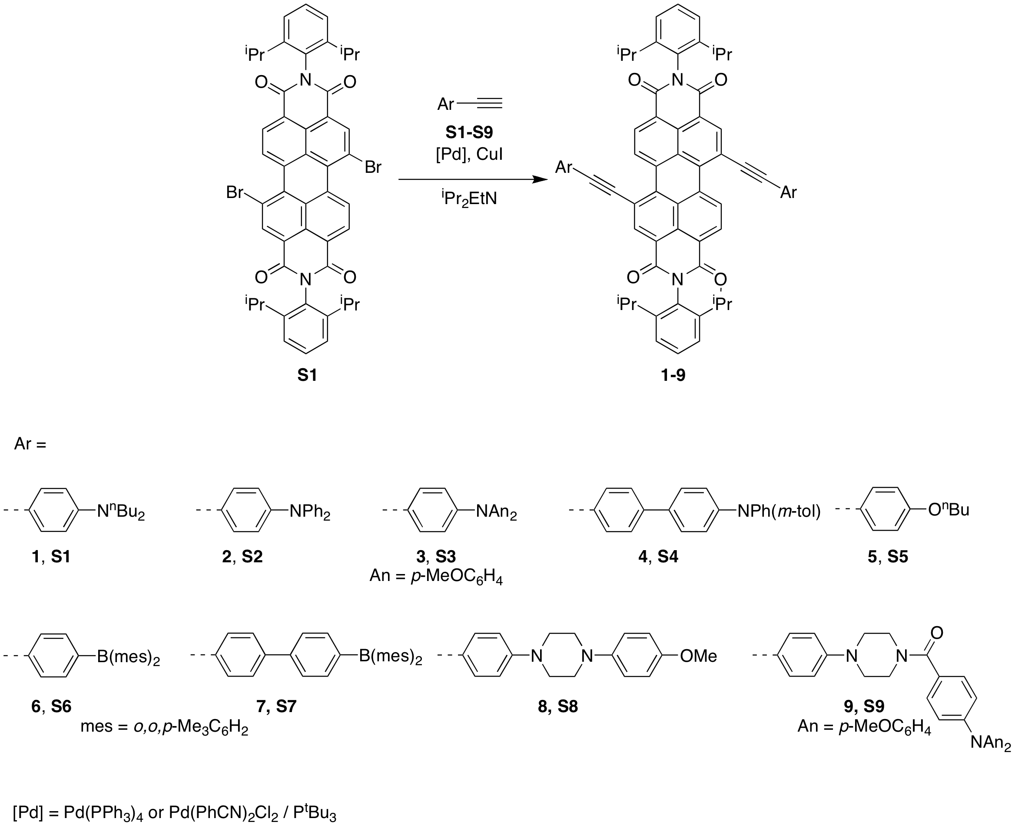
Figure 1. Scheme for synthesis of bis(arylethynyl)PDIs {An = p-MeOC₆H₄}.
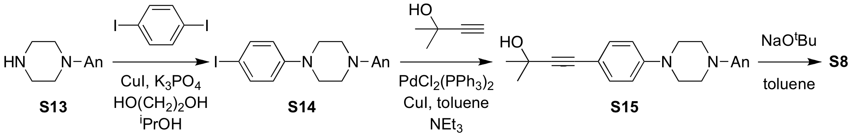
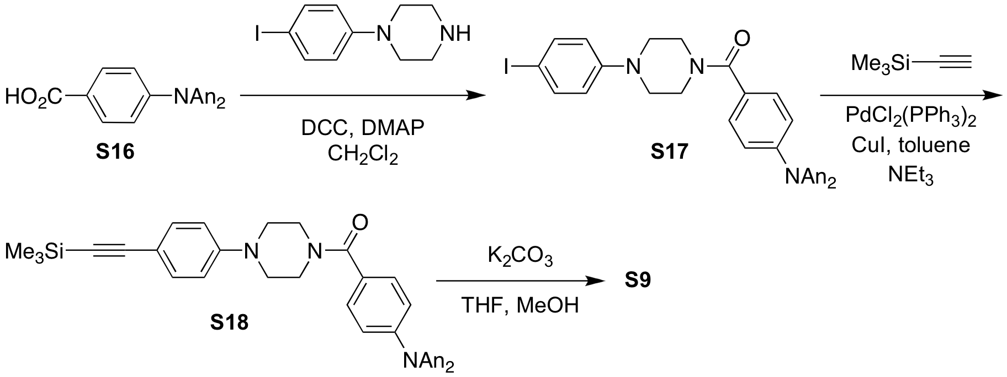
Figure 2. Synthesis of intermediate alkynes S8 and S9.
The new D'…D-A-D…D' PDIs were synthesized as shown in Figure 1. The alkyne starting materials, S8 and S9, were synthesized as shown in Figure 2. Cyclic voltammetry has been used to compare 8 and 9 with 1. The absorption spectra (Figure 3a) are similar to those for 1, i.e., they show a perylene-diimide-like absorption at <500 nm and a low-energy charge-transfer-like feature. The new compounds show additional reversible oxidation; the potentials corresponding to mono- and dication formation in these two species are less anodic than for 1 suggesting that it is the secondary donors that are oxidized in first and that the donors conjugated to the perylene diimide core are only oxidized when the tri- and tetracations are formed. Comparison with model compounds further supports this hypothesis. Chemical oxidation of 9 offers further support that the secondary donor is the preferred location for a hole (at least in the absence of an extra electron on the PDI); Figure 3b shows that the formation of a triarylamine radical cation absorption at ca 800 nm. Our hope was then that photoexcitation would lead to a charge separation between D and A groups and that a second electron-transfer from D' to D⁺ would then lead to a long-lived charge-separated state. Such long-lived states might be useful in photovoltaic devices and, depending on their absorption spectra, for use as a part of optical pulse suppression systems. However, transient absorption experiments, again in collaboration with Wasielewski, reveal that the recombination times for 8 and 9 are respectively much shorter than and similar to that found for 1. It is possible that the secondary charge separation is hampered by electrostatic interactions in the first-formed excited state. Moreover, regardless of whether this happens, the back electron-transfer is governed by a complex interplay of driving force, reorganization energy, and electronic coupling. Future more sophisticated designs will have to be developed to afford more reliable secondary charge-separation.
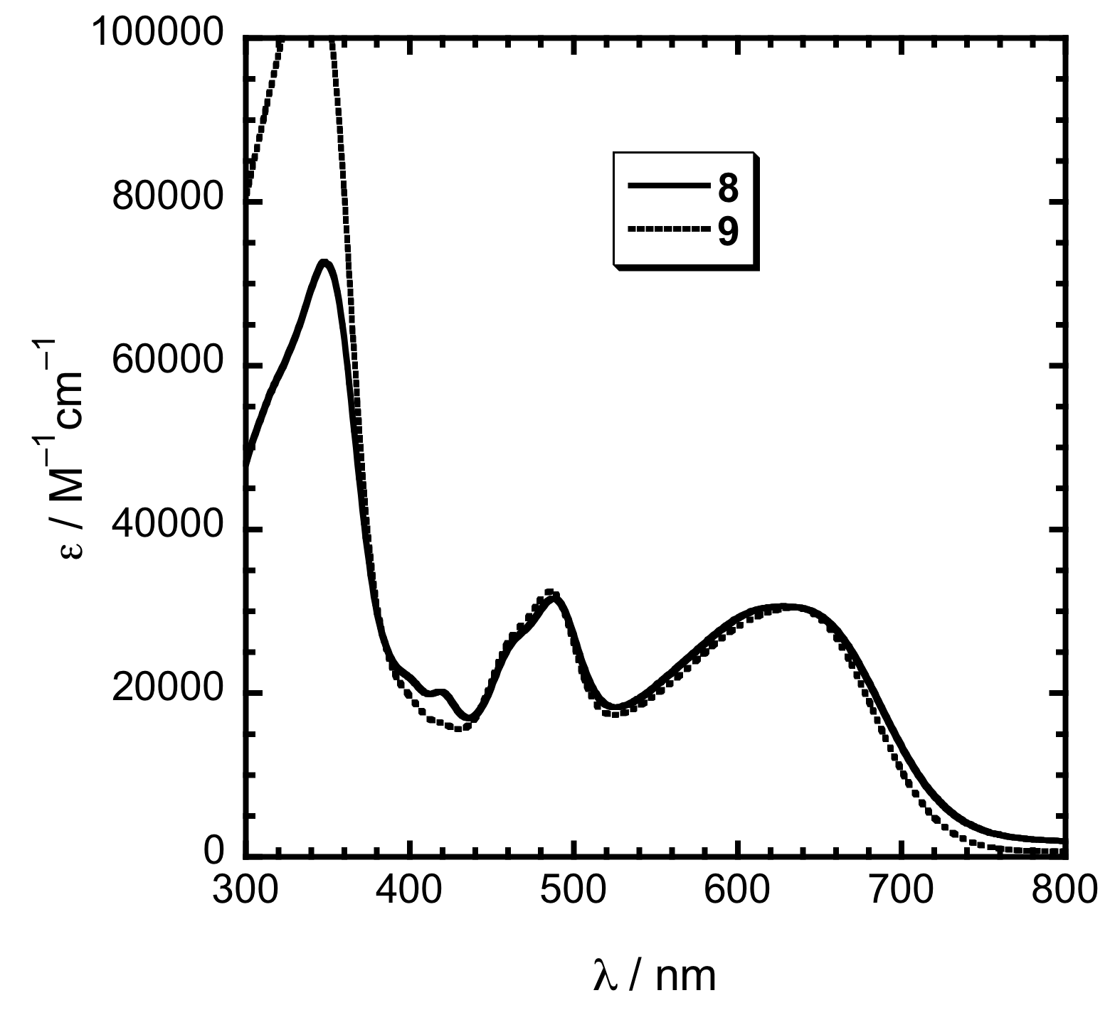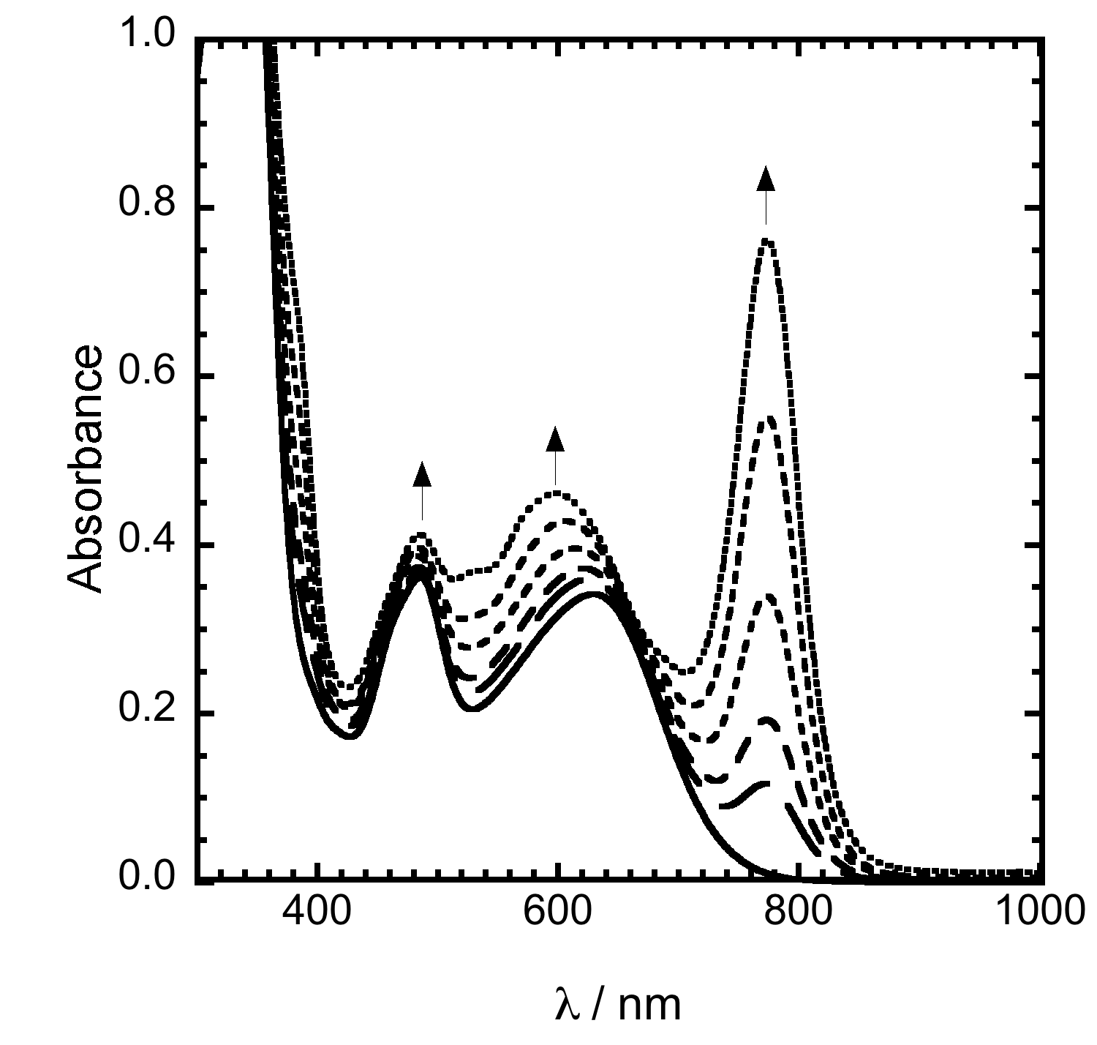
Figure 3. Left: absorption spectra of 8 and 9. Right: evolution of the absorption spectra of 9 on addition of an oxidizing agent.

2. Synthesis of perylene diimide / carbazole polymers.
Perylene diimides (PDIs) attached to conjugated polymers may be of interest as systems exhibiting (one or two-photon-induced) photoinduced charge separation. This charge separation may be of use for either optical pulse suppression or photovoltaic applications. We have successfully synthesized PDIs grafted to 2,7-dibromo and 3,6-dibromo-carbazole monomers (Figure 4) for further polymerization to give the corresponding PDIs grafted polycarbazoles. However, we have had limited success as polymerizing the dibromo derivatives. Therefore, as shown in Figure 5, a diiodo monomer was synthesized and used for polymerization. As expected, the much more active iodine here facilitates polymerization, although only low molecular-weight materials have been obtained so far (with a degree of polymerization was found to be around 4 according to the GPC result on the crude product). The absorption spectra of the polymer in solution showed the extra peaks at 200-350 nm compared to the monomer, which also indicated the forming of the oligomers.
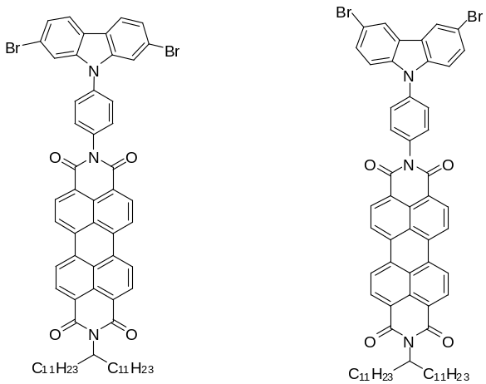Figure 4. Structures of perylene-dimide / carbazole monomers.
3. Carbazole-based Monomers and Polymers as Hosts for Phosphors
Figure 5. Synthesis and polymerization of diiodo monomers.
We are interested in the synthesis of building blocks, monomers, oligomers, and polymers with potentially interesting electronic and / or optical properties. Increasingly, organic light-emitting diodes (OLEDs) incorporate phosphorescent heavy-metal complexes, such as those of Ir and Pt, as lumophores in order that both singlet and triplet states resulting from electron and hole recombination can be harvested. Typically the heavy-metal complexes are dispersed within a host material with appropriate energy levels to facilitate the injection of both holes and electrons and with a sufficiently high triplet energy to allow for both singlet and triplet energy transfer to the heavy-metal guest of interest. Copolymerization of host and guest monomers offers a means of creating solution-processable emissive layers in which the possibility of phase separation is reduced and in which there is a possibility of controlling guest-guest and host-guest aggregation phenomena. One of the most widely used of these hosts is 4,4'-bis(carbazol-9-yl)biphenyl, CBP. We have previously reported a norbornene derivative of bis(carbazolyl)fluorene (Figure 6) and its copolymerization with platinum and iridium monomers.^{1,2}
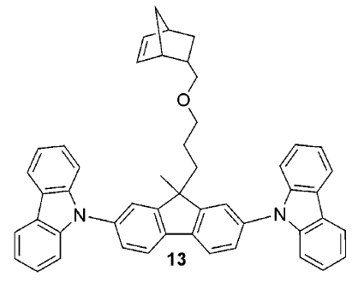
Figure 6. Previously synthesized norbornene host monomer.
We have now synthesized a range of other carbazolyl monomers. Figure 7 shows the synthesis of a host monomer and the corresponding homopolymer containing a similar bis(carbazolyl)biphenyl building block. The monomers (and polymers) of Figures 6 and 7 are expected to show similar triplet energies,³ ionization potentials, and electron affinities. However, the different point of attachment of the polymer chain may alter the morphology of polymers and may affect host-guest aggregation. We have also synthesized polymerizable versions of the so-called mCP and mCPy host materials (Figures 8 and 9). The corresponding small molecules have been used as hosts for Ir and Pt phopshors. In particular, mCP has been shown to be a more effective host for blue Ir phosphors, such as iridium(III)bis[2-(4,6-difluorophenyl)pyridinato-N,C^{2'}]picolinate, than CBP due to its higher lying triplet energy.⁴ On the other hand, efficient white OLEDs have been made using emissive layers composed of a Pt phosphor guest, Platinum(II) 2-(4',6'-difluorophenylpyridinato-N,C^{2'})(pentane-2,4-dionato-O,O), which exhibits blue molecular emission and orange excimer emission, and a mCPy host.⁵ Improved performance relative to a mCP device was observed; one explanation advanced was that the electron-poor pyridine ring led to a more balanced injection of holes and electrons into the emissive layer. We are currently investigating the photoluminescence properties of host-guest systems composed of these polymers and metal-complex phosphors and use of these blends in organic light-emitting diodes. Based on these results, hosts with copolymerized with appropriate guest monomers.
Figure 7. Synthesis of a bis(carbazolyl)biphenyl host norbornene monomer.
Figure 8. Synthesis of mCP host norbornene monomer.

Figure 9. Synthesis of mCP host norbornene monomer.

4. Phthalocyanine Side-Chain Monomer and Polymers
Phthalocyanines (Pcs) are another functionality of interest for organic electronic applications, particularly for use in solar cells, with CuPc being probably the most widely used. Most work with Pcs in solar cells has been limited to vacuum-processed materials. One possible method to facilitate solution processible Pcs would be to attach Pc building blocks to the side chain of a polymer. Moreover, ROMP offers the possibility of creating self-phase-segregating block polymers with donor a Pc block and another acceptor block. Pcs are also of interest for another DOD application: optical pulse suppression. The relatively weak linear aborption in the ca. 400-600 nm range, coupled with a strong triplet absorption in this range, makes examples in which high intersystem crossing rates can be achieved efficient reverse saturable absorbers in this wavelength range.⁶ For applications, films consisting of high chromophore densities are required; however, it is important that the linear and nonlinear optical films of these materials are not adversely affected by the tendency of Pcs to aggregate. Side-chain polymers offer a possible means of incorporating high concentrations of Pcs in solution-processible films, while possibly also impairing Pc aggregation. We have begun synthetic studies aimed at such polymers using ZnPc as our initial building block, due to its simplicity and diamagnetism (and hence ease of NMR characterization). If successful, we anticipate that our methodology can be adapted to synthesize CuPc polymers for photovoltaic applications. For optical pulse supression, we can either use heavy-metal Pcs or copolymerize ZnPc with heavy-atom-containing comonomers, as shown in Figure 9. Figure 10 shows one possibility based on cocyclization of a norbornene-functionalized phthalonitrile with tert-butylphthalonitrile. Unfortunately, the desired product is similar in polarity and size to the tetra-(tert-butyl)-ZnPc side product, making separation by column chromatography and size-exclusion chromatography difficult. Figure 11 shows an alternative route to a norbornene-Pc monomer. Although this route requires an additional step, the polar alcohol functionality allows separation of a mono-functionalized Pc in moderate yield after two columns. We anticipate that this alcohol should be readily esterified to a norborene monomer as shown; this work is currently in progress.
Figure 11. Attempted synthesis of a norbornene-functionalized ZnPc.
Figure 10. Proposed Pc / iodinated copolymer for optical pulse suppression studies.

References
(1) Cho, J.-Y.; Domercq, B.; Barlow, S.; Suponitsky, K. Y.; Li, J.; Timofeeva, T. V.; Jones, S. C.; Hayden, L. E.; Kimyonok, A.; South, C. R.; Weck, M.; Kippelen, B.; Marder, S. R. Organometallics 2007, 26, 4816.
Figure 12. Alternative route to a norbornene-functionalized ZnPc.
(2) Kimyonok, A.; Domercq, B.; Haldi, A.; Cho, J.-Y.; Carlise, J. R.; Wang, X.-Y.; Hayden, L. E.; Jones, S. C.; Barlow, S.; Marder, S. R.; Kippelen, B.; Weck, M. Chem. Mater. 2007, 19, 5602.
(3) Marsal, P.; Avilov, I.; da Silva Filho, D. A.; Brédas, J. L.; Beljonne, D. Chem. Phys. Lett. 2004, 392, 521.
(4) Holmes, R. J.; Forrest, S. R.; Tung, Y.-J.; Kwong, R. C.; Brown, J. J.; Garon, S.; Thompson, M. E. Appl. Phys. Lett. 2003, 82, 2422.
(5) Williams, E. L.; Haavisto, K.; Li, J.; Jabbour, G. E. Adv. Mater. 2007, 19, 197.
(6) Perry, J. W.; Mansour, K.; Lee, I.-Y. S.; Wu, X.-L.; Bedworth, P. V.; Chen, C.-T.; Ng, D.; Marder, S. R.; Miles, P.; Wada, T.; Tian, M.; Sasabe, H. Science 1996, 273, 1533.

